Imagine that you are a technical business analyst for an organization. The organization’s leadership anticipates that they will soon need to move the on-premises systems to a cloud-based system. They want to fully understand how on-premises solutions compare to the same solutions hosted in the cloud. They also want to know the specific business requirements that would influence their decision to move to a cloud-based system. Therefore, you are asked to research the information associated with a cost analysis.
However, you will not perform all of the tasks typically associated with a cost analysis in the field. You will analyze what leadership must consider for a cost analysis of cloud versus on-premises solutions. Your information will determine when, where, and how the organization should make this technological change. You are not conducting the cost analysis yet. However, you need to emphasize to leadership all the components of this change that must be considered.

Directions
Create a document, table, or visual to prepare for a cost analysis of a cloud-based solution compared to an on-premises solution based on the following business requirements:
- Support for proxy authentication
- Role-based management
- Encryption on storage and transmission
In your work, you must address what leadership should consider for both cloud-based and on-premises solutions. Specifically, the following rubric criteria must be met:
Personnel
- Who will you need to hire for each solution?
- What kind of staff is needed for each solution?
Hardware and Software
- What hardware and software will you need for each solution?
Utilities
- What are the utility concerns, such as electricity and cooling, for each solution?
Security
- What are the security concerns for each solution, and how is information secured on each solution?
Potential Costs
- What are the potential costs for each solution, based upon these components?
  - You are encouraged to use the AWS Pricing Calculator in the Supporting Materials section to estimate the costs, but you may use other resources or tools. Keep in mind that this is only an estimate, but you should calculate based on what you indicated as answers in the previous questions.

Physical server:

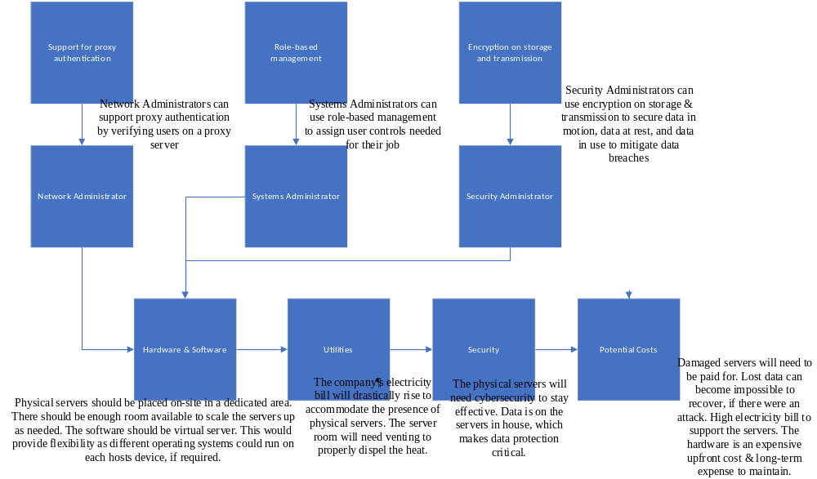

Cloud Server:
